Total marks: 55 (only need 50 to get 100%)
Word Problems:
- Mark each of the following statements as either descriptive (D) or
inferential (I). [3]
  - The odds of being struck by lightning are about 700,000 to 1. Inferential
  - 14.5% of all cancer cases in 2001 were lung cancer. Inferential
  - 28.5% of female cancer cases reported in the
Canadian Cancer Statistics 2005 study were breast cancer. Descriptive
- Mark each of the following variables as nominal (N), ordinal (O), discrete (D), or continuous (C): [5]
  - The oil temperature of a car engine Continuous
  - A student’s hometown (city of birth) Nominal
  - The number of people waiting in queue at the bank Discrete
  - The final letter grade for a course at TWU Ordinal
  - Whether a person likes pineapple (i.e., true/false) Nominal
- Describe an example of two events that are independent. Be sure to describe the complete sample space as well. [3]
There are many possible answers; a simple one is flipping a coin multiple times: the event “heads on first flip” is independent of the event “heads on second flip”. The whole sample space is { (H,H), (H,T), (T,H), (T,T) }.
- Assume the table below represents the raw data for an experiment measuring wind speed at a particular airport. Draw a frequency histogram, classifying the data by tens of kph. [4]
5 kph | 8 kph | 15 kph
15 kph | 18 kph | 19 kph
22 kph | 27 kph | 42 kph
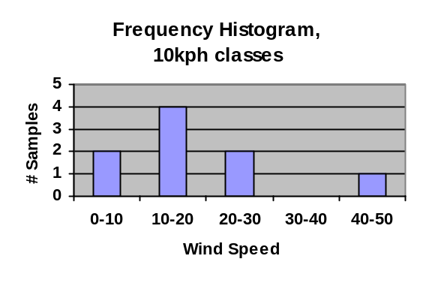
- Using the same data from the previous problem, draw a relative frequency histogram, classifying the data in groups of 20 kph. [3]
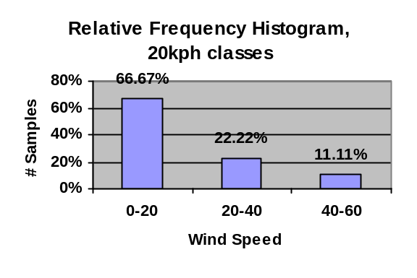
- (Show all work and draw a box around your final answer.) Using the same data from the previous problem, give the
  - Mean [2]
19 kph
  - Median [1]
18 kph
  - First quartile (1/4) [1]
15 kph
  - Third quartile (3/4) [1]
22 kph
  - Mode [1]
15 kph
  - Mean absolute deviation (MAD) [3]
~ 7.56 kph
  - Variance (either n or n-1 version) [4]
~105.78 (n) or 119 (n-1)
  - Standard deviation [1]
~10.28 (n) or ~10.91 (n-1)
- A bag contains 4 red marbles and one blue marble. Three marbles are drawn from the bag, without replacement.
  - Draw a tree diagram representing the sample space (list only outcomes that can actually occur). Annotate your tree diagram with probabilities for each branch of the tree and for each final outcome. [8]
R: 4/5
B: 1/5
R: 3/4
B: 1/4
R: 4/4
R: 3/3
(R, R, R): 2/5
(R, R, B): 1/5
(R, B, R): 1/5
R: 2/3
R: 3/3
B: 1/3
(B, R, R): 1/5
  - What are the odds of finding the blue marble in these three tries? [2]
Probability is (1/5)+(1/5)+(1/5) = 3/5
Odds are 3:2 in favor
- Let A represent students with financial aid. Let B represent students from BC. In the boxes provided, draw Venn diagrams shading in each region described:
  - 7% of all students are from BC and also have financial aid. [2]
A
B
  - 55% of students are neither from BC nor have financial aid. [2]
A
B
- We are also told that 25% of BC students have financial aid. Given the above probabilities, what percentage of students are from BC? [4]
P(A|B) = 25%
P(A|B) = n(A∩B) / n(B)
25% = 7 / n(B)
P(B) = 28% of students
- What fraction of students have financial aid? [3]
P(A) = P(A u B) – P(B) + P(A∩B)
= (100% - 55%) – 28% + 7%
= 24%
- Are the two events A and B independent? Why or why not? [1]
No. P(A) = 24% and P(A|B) = 25% are not the same.
- Are the two events A and B mutually exclusive? Why or why not? [1]
No. P(A∩B) = 7% is not zero,
which means the intersection is not null,
i.e., there are students who are both BC and with aid.

